 | Title : Project Registration & Progress Review |  | FF No. 180
Department: AIML |  | Academic Year: 2025-26
Semester : 3 |  | Group No. : 5
Project Title: AI and Blockchain-Based System for Visual Quality Grading and Traceability of Fruits in Supply Chains
Project Area: Agricultural Technology (AgriTech) & Blockchain
Group Members Details:

Sr. No. | Class & Div. | Roll No. | G.R.No. | Name of Student | Contact No. | Email ID
1 | CSAIML_A | 7 | 12414240 | ABHINANDAN BARDIA | 93022 21467 | abhinandan.bardia24@vit.edu
2 | CSAIML_A | 8 | 12414243 | ABHISHEK ANIL PATIL | 9011019161 | abhishek.patil241@vit.edu
3 | CSAIML_A | 12 | 12411764 | ADITI KAMLAKAR PATIL | 9067310282 | aditi.patil241@vit.edu
4 | CSAIML_A | 14 | 12413066 | ADITYA RAJSINGH KACHWAHA | 7972898114 | aditya.kachwaha24@vit.edu
5 | CSAIML_A | 18 | 12414343 | AGHAV VED NAMDEV | 9075208377 | ved.aghav24@vit.edu

Name of Internal Guide : Contact No. & Email ID:
PROF. (DR.) VARSHA DANGE 95525 47248 varsha.dange1@vit.edu

Project approved / Not approved

Guide Project Coordinator Head of Department

T
FF No 180
Project Synopsis
Project Title:
AI and Blockchain-Based System for Visual Quality Grading and Traceability of Fruits in Supply Chains

Problem Statement:
In traditional agricultural supply chains, there is a lack of reliable, transparent, and tamper-proof systems for evaluating and tracking the quality of produce like fruits. Manual fruit grading is subjective, error-prone, and lacks traceability — making it difficult for stakeholders to verify the quality and origin of agricultural goods.

Abstract:
This project aims to automate the fruit grading process using a machine learning model and secure the grading results using blockchain technology. The ML model will classify fruits into grades (A, B, C) based on visual features. The grading information, along with metadata (date, location, quality parameters), will then be stored on a decentralized blockchain ledger to ensure immutability and transparency. This system is especially beneficial for stakeholders across the agricultural supply chain, ensuring fair trade, reducing fraud, and improving product quality tracking.

Introduction:
Agricultural product grading is vital for determining pricing, storage, and distribution decisions. However, current grading systems often rely on manual inspections that vary based on human judgment and are not reliably documented. By combining machine learning with blockchain, this project introduces a smart, traceable, and transparent fruit grading system that enhances both quality assurance and supply chain credibility.

Objectives:
- To automate the fruit grading process using a trained machine learning model.
- To ensure transparency and traceability of grading results using blockchain.
- To eliminate tampering or misreporting of product quality.
- To provide stakeholders with easy access to fruit quality history via decentralized records.
- To improve efficiency and trust across the agricultural supply chain.

Key Features:
- Real-time fruit image capture and grading.
- ML-based classification into A, B, or C grades.
- Secure storage of grading results on blockchain.
- Traceable grading history and metadata (location, timestamp).
- Web interface for viewing and verifying results.
- Tamper-proof and verifiable certification.

Technology Stack:
- Model Training & Image Processing: Python, TensorFlow, OpenCV
- Backend & API Integration: Flask, Supabase, QR Code Library
- Blockchain & Decentralized Storage: IPFS, Solidity, Polygon Testnet, MetaMask
- Frontend Development: HTML, CSS, JavaScript, Web3.js
- Connectivity & Integration Tools: MetaMask, Web3.js, QR Code Library

Benefits:
- Fully automated and consistent fruit quality evaluation.
- Immutable and tamper-proof grading records.
- Improved farmer-to-market trust and transparency.
- Fairer pricing and reduced product rejection rates.
- Easier audits, certifications, and compliance reporting.

Conclusion:
This project bridges the gap between agricultural quality control and modern-day digital trust systems. By integrating machine learning and blockchain, it provides a scalable, transparent, and intelligent fruit grading solution. The system empowers all stakeholders — from farmers to consumers — with reliable data, reducing fraud and inefficiencies in the food supply chain.

Workflow

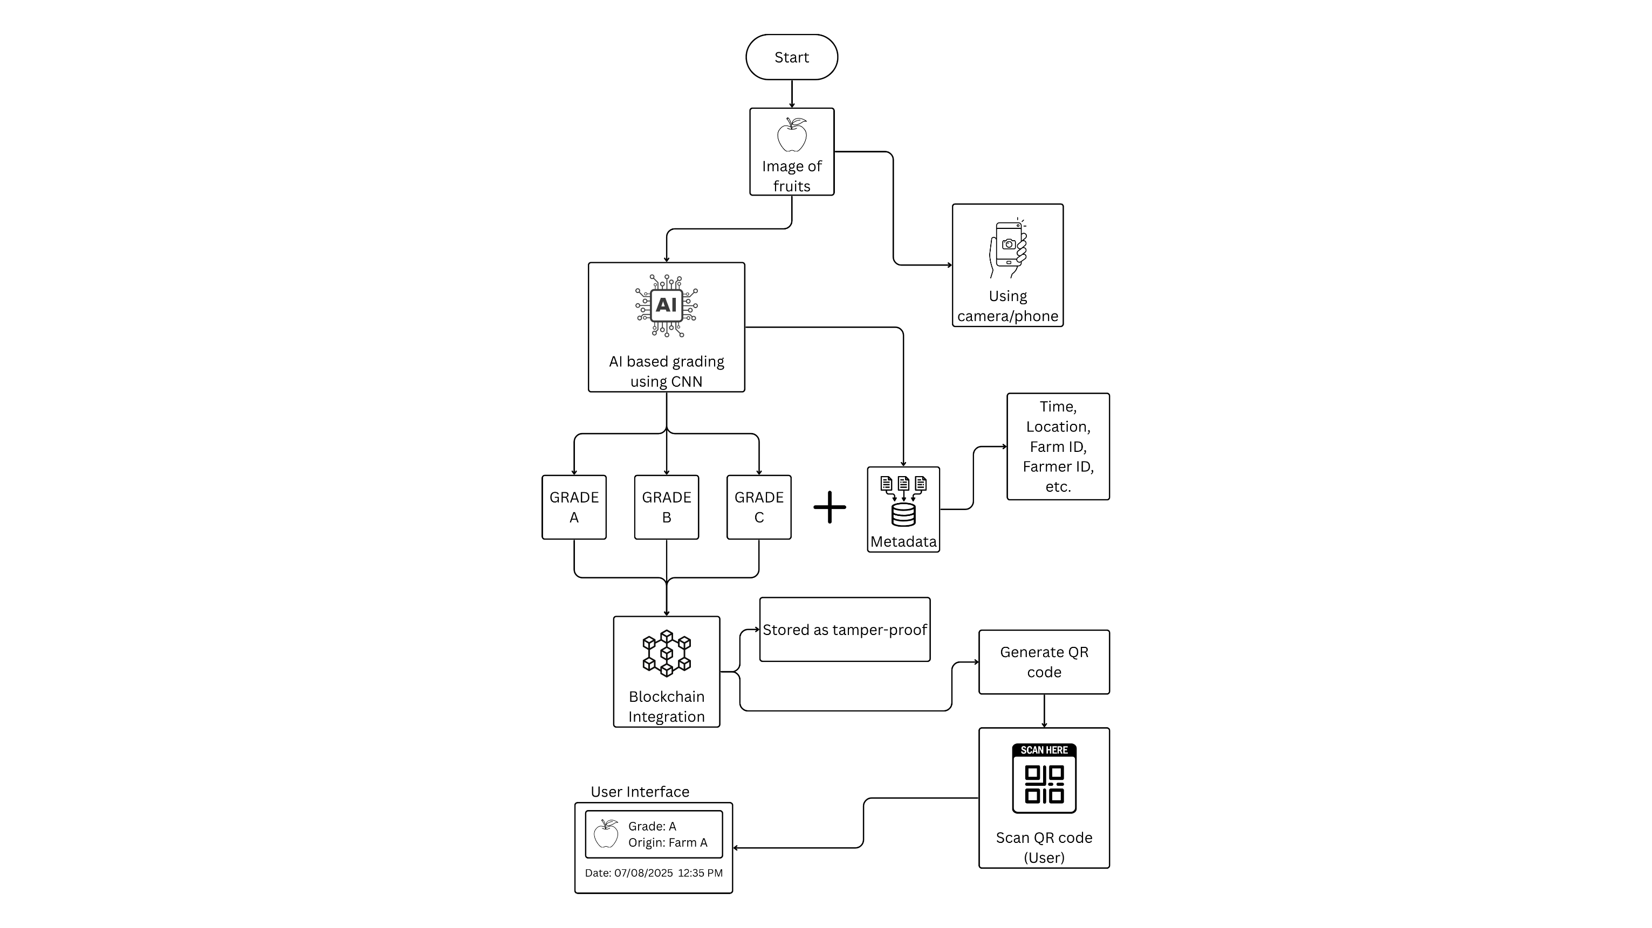

Literature Review

No | Title (Source, Date) | Project Idea | Tech Stack | Limitations | Our Improvement
1 | “Deep learning-based fruit grading using hyperspectral and RGB imaging” (IEEE Trans. on Instrumentation, Aug 2024) | Use hyperspectral imaging + CNN to grade fruit ripeness and defects | CNN, hyperspectral + RGB sensors | Specialized expensive hardware, limited scalability | Use standard RGB, reduce cost, apply CNN/ViT and simpler capture
2 | “Blockchain-based traceability for fresh produce supply chain” (IEEE Access, Sep 2024) | Record supply-chain events (farm, transport, storage) into blockchain | Ethereum smart contracts, off-chain DB, IoT sensors | No automated grading; manual data entry | Integrate automated ML grading as certified data input
3 | “AI-enabled apple defect detection using vision transformers” (IEEE CCIS, Jul 2025) | ViT model to detect blemishes and grade apples | Vision Transformer (ViT), Python, OpenCV | Focus only on apples; no traceability | Extend to multiple fruit kinds and add blockchain storage
4 | “Smart agriculture traceability using Hyperledger and ML forecasting” (IEEE Access, Nov 2024) | Use Hyperledger Fabric + ML to forecast demand and trace products | Hyperledger, Python ML, IoT | No image-based quality inspection | Add image-based grading pipeline feeding into the ledger
5 | “ML-driven defect detection in citrus fruits via CNN ensemble” (IEEE Access, Jun 2025) | Ensemble CNN models classify citrus from class A-C | Multiple CNNs, large image dataset | Only citrus fruits; no metadata traceability | Broaden fruit set, integrate blockchain metadata storage

FF No 180

Group No.
Activity | Review Schedule | Progress Review Report submitted | Signature of Guide
Review 1 | Mid Sem. Semester | Yes / No
Review 2 | End of Semester | Yes / No

Format of Progress Review Report:

Review No.: 1 Group No.: Date:

Progress Review Report

Signature of Guide:

Review No.: 2 Group No.: Date:

Progress Review Report

Signature of Guide:

